2018 CALDWELL PARISH HEALTH AWARENESS DAY VENDOR REGISTRATION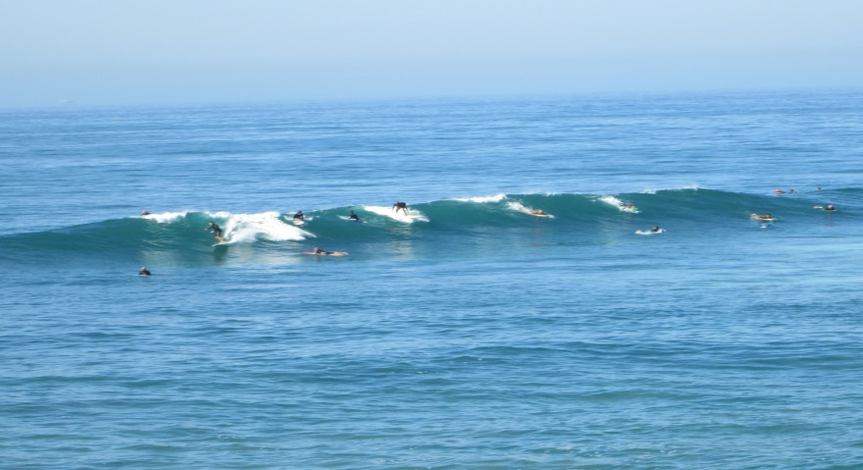
“CATCH THE WELLNESS WAVE!”
________Yes, we plan to attend ___ $20.00 Donation
________No, we do not plan to attend
Business Name: _________________________________________________________
Contact Person: _________________________________________________________
Phone: ____________________________ Fax: ________________________________
Address: _________________________________________________________________
Email Address: __________________________________________________________
For food purposes, we need to know how many representatives from your company will be attending? ____________________________________________________
Special needs for Exhibit: [ Ex. Electricity ] ____________________________
Will you be offering any services such as BP checks, screening exams,
etc? _______________________________________________________________________
Will you be offering any specific topics for education?__________________
_____________________________________________________________________________
Other comments or suggestions: _________________________________________
_____________________________________________________________________________
Mail to: Caldwell Parish Council on Aging, P.O. Box 1498, Columbia, LA 71418 - DON’T FORGET TO ENCLOSE YOUR $20 FAX TO: 318-649-7600, ATTN: DOTTIE ETHERIDGE or KELLY ESTIS

